Insert your centre number, name and candidate number into the header above.
Save this evidence document as evidence_ followed by your centre number_ candidate number. For example: evidence_ zz999_9999
Screenshots or program listings must be copied into appropriate cells in the following table.
Examiners must be able to read the contents including any screenshots without the use of a magnifying glass. Answers that are not readable or missing will not be awarded any marks.
Save this evidence document at regular intervals, for example every 10 minutes.
Question 1
Part 1(a)
#StackData Integer
#StackPointer Integer

global StackData
global StackPointer

StackData = [0 for i in range (10)]
StackPointer = 0
Part 1(b)
def PrintAll ():
for i in range (10):
print (StackData[i])
print (StackPointer)
Part 1(c)
def Push(NewInteger):
global StackPointer
global StackData
if (StackPointer == 10):
return False
else:
StackData[StackPointer] = NewInteger
StackPointer = StackPointer + 1
return True
Part 1(d)(i)
for i in range (11):
NewInteger =input("Enter a new integer: ")
if Push(NewInteger) ==True:
print ("Successfully added to the stack")
else:
print ("Failed to add to the stack")
Part 1(d)(ii)
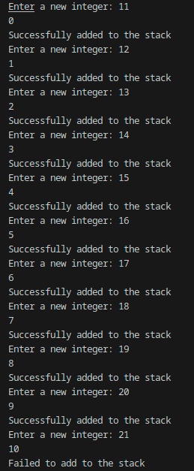
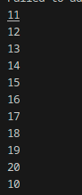

Part 1(e)(i)
for i in range(11):
NewInteger = input("Enter a new integer: ")
if Push(NewInteger) == True:
print("Successfully added to the stack")
else:
print("Failed to add to the stack")

Part 1(e)(ii)
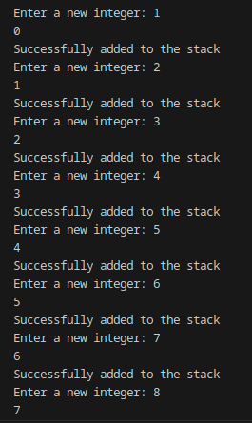
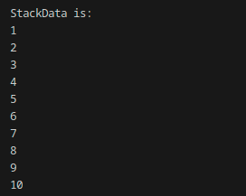
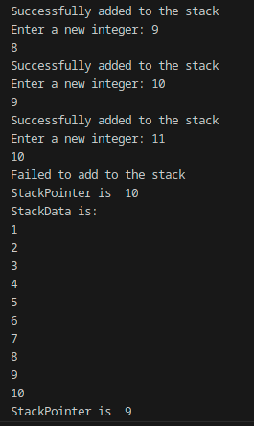

Question 2
Part 2(a)
{import random
# IntegerArr [10][10]
IntegerArr = [[0 for i in range(10)] for j in range (10)]

for i in range (10):
for j in range (10):
IntegerArr[i][j] = random.randint(1,100)
Part 2(b)(i)
ArrayLength = 10
for x in range(0, ArrayLength):
for y in range(0, ArrayLength - 1):
for z in range(0, ArrayLength - y - 1):
if ArrayData[x][z] > ArrayData[x][z + 1]:
TempValue = ArrayData[x][z]
ArrayData[x][z] = ArrayData[x][z + 1]
ArrayData[x][z + 1] = TempValue
Part 2(b)(ii)
def PrintArray(ArrayData):
for i in range (10):
for j in range (10):
print (ArrayData[i][j], end=" ")
print ("")

print ("before sorting:")
PrintArray(ArrayData)

ArrayLength = 10
for x in range(0, ArrayLength):
for y in range(0, ArrayLength - 1):
for z in range(0, ArrayLength - y - 1):
if ArrayData[x][z] > ArrayData[x][z + 1]:
TempValue = ArrayData[x][z]
ArrayData[x][z] = ArrayData[x][z + 1]
ArrayData[x][z + 1] = TempValue

print ("after sorting:")
PrintArray(ArrayData)
Part 2(b)(iii)
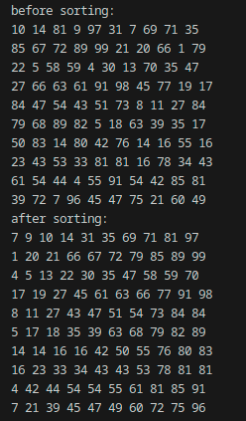
Part 2(c)(i)
def BinarySearch(SearchArray, Lower, Upper, SearchValue):
if (Upper >= Lower):
Mid = int((Lower + (Upper - 1)) / 2)

if (SearchArray[0][Mid] == SearchValue):
return Mid
else:
if (SearchArray[0][Mid] > SearchValue):
return BinarySearch(SearchArray, Lower, Mid - 1, SearchValue)
else:
return BinarySearch(SearchArray, Mid + 1, Upper, SearchValue)
return -1
Part 2(c)(ii)
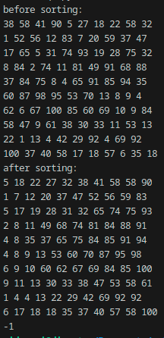
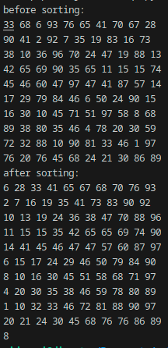

Question 3
Part 3(a)
class Card:
# Number Integer
# Color String
def __init__(self, num, col):
self.__Number = num
self.__Color = col

Part 3(b)
def GetNumber(self):
return self.__Number
def GetColor(self):
return self.__Color
Part 3(c)
# ArrayCard[30] Integer
ArrayCard = [Card("","") for i in range (30)]
for i in range (30):
file = open('./CardValues.txt')
num = int(file.readline)
col = file.readline
NewCard = Card(num, col)
ArrayCard[i] = NewCard

file .close('./CardValues.txt')
Part 3(d)
global TakenCards
TakenCards = [3, 4]

def ChooseCard():
global TakenCards
while True:
PickingCard = int(input("Choose a card: "))

if PickingCard >= 1 and PickingCard <= 30:
TakenCheck = False

for i in range(len(TakenCards)):
if PickingCard == TakenCards[i]:
TakenCheck = True
if (TakenCheck) == False:
TakenCards.append(PickingCard)
break

else:
print("Card already taken")
else:
print("Number needs to be between 1 and 30")

return (PickingCard -1)

Part 3(e)(i)
# Player1 [] Card
Player1 = []
for i in range(4):
NewCardIndex = ChooseCard()
NewCard = ArrayCard[NewCardIndex]
Player1.append(NewCard)
for i in range(4):
print(Player1[i].GetNumber())
print(Player1[i].GetColour())

Part 3(e)(ii)
